##### TP WESTERN ODISHA DISTRIBUTION LIMITED

**(A Tata Power & Odisha Govt. Joint venture)**

**Corporate Office, Burla-768017**

##### Procedure to Participate in E-Tender Tender Enquiry No- TPWODL/PJ/O/SU/001

|  |  |  |  |  |
| --- | --- | --- | --- | --- |
| **Tender Enquiry No.** | **Job Description** | **EMD (Rs.)** | **Tender Participation Fee including GST** | **Last date and time for Payment of Tender Participation Fee** |
| TPWODL/PJ/O/SU/001 | Supply of 8MVA, 33/11KV, 3-Ø, Cu. Wound, ONAN type, Power Transformer as per the list (Annexure – I enclosed). | 2.0Lakh | Rs. 5900.00 | 15.04.2023, 15.00 Hrs. |

**Please note that corresponding details mentioned in this document will supersede any other details mentioned anywhere else in the Tender Document.**

##### Procedure to Participate in Tender.

Following steps to be done before “Last date and time for Payment of Tender Participation Fee” as mentioned above

1.

1. **For Regular Bidders**- Non-Refundable Tender Participation Fee, as indicated in table above, to be submitted in the form of direct deposit in the following bank account and submit the receipt along with a covering letter clearly indicating the Tender Reference number –

##### Beneficiary Name : TPWODL Expenditure Account Bank Name : Union Bank of India

**Branch Name** **: Sambalpur Naya Para**

##### Address : At/P.O.- Sambalpur, Dt: Sambalpur, Odisha-768 001

**Branch Code** **536521**

##### Account No. 365201010033244

**Account Type** **: Current**

##### IFSC Code : UBIN0536521

1. **For MSME Category Bidders**- Bidders from MSME category shall pay Rs.1,000/- (including GST) towards cost of tender paper and have to pay only 50% EMD amount.

Local MSME Registered in the State of Odisha refer to Annexure-XI **(Norms for procurement from MSMEs registered in the state of Odisha**) for details of tender participation.

Interested MSME bidders are required to submit undertaking with valid registration certificate before last date and time of tender purchase.

1. **Authorization letter**- Eligible and Interested Bidders to submit duly signed and stamped letter on Bidder's letterhead indicating
   1. Tender Enquiry number
   2. Name & Address of the Bidder
   3. Name of authorized person
   4. Contact number
   5. e-mail id
   6. Details of submission of Tender Participation Fee
   7. GST Registration No

E-mail with necessary attachment of 1 and 2 above shall be sent to priyabrat.jena@ tpwesternodisha.com with a copy to [ajit.singh@tpwesternodisha.com](mailto:ajit.singh@tpwesternodisha.com) before last date and time for payment of Tender Participation Fee.

Interested bidders to submit Tender Participation Fee and Authorization Letter before Last date and time as indicated above after which link from TPWODL E-Tender system (Ariba) will be shared for further communication and bid submission.

Please note all future correspondence regarding the tender, bid submission, bid submission date extension, Pre-bid query etc. will happen only through TPWODL E- Tender system (Ariba). User manual to guide the bidders to submit the bid through E- Tender system (Ariba) is also enclosed.

No e-mail or verbal correspondence will be responded. All communication will be done strictly with the bidders who have done the above step to participate in the Tender.

Also, it may be strictly noted that once date of “Last date and time for Payment of Tender Participation Fee” is lapsed no Bidder will be sent link from TPWODL E-Tender System (Ariba). Without this link BA will not be able to participate in the tender. Any last moment request to participate in tender will not be entertained.

Any payment of Tender Participation Fee by Bidder who have not done the prerequisite will not be refunded.

Also, all future corrigendum’s to the said tender will be informed on Tender section on website https://[www.tpwesternodisha.com.](http://www.tpwesternodisha.com/)

**NIT No.:** TPWODL/PJ/O/SU/001



**Tender Documents**

***Property of TPWODL – Not to be reproduced without prior written permission of TPWODL***



**OPEN TENDER NOTIFICATION**

**for**

# Supply of 8MVA, 33/11KV, 3-Ø, Cu. Wound, CRGO CORE, ONAN type, Power Transformer.

**Tender Enquiry No.: TPWODL/PJ/O/SU/001**

**Due Date for Bid Submission: 8th. May-2023 [15:00 Hrs.]**

TP Western Odisha Distribution Limited (TPWODL) Burla , Sambalpur - 768017



**CONTENTS OF THE ENQUIRY**

**Contents**

|  |  |
| --- | --- |
| **1.0** | **Event Information** 3 |
| **2.0** | **Evaluation Criteria**5 |
| **3.0** | **Submission of Bid Documents** 5 |
| **4****.0** | **Bid Opening & Evaluation process** 8 |
| **5****.0** | **Award Decision** 9 |
| **6****.0** | **Order of Preference/Contradiction** 9 |
| **7****.0** | **Post Award Contract Administration** 9 |
| **8****.0** | **Specification and standards** 11 |
| **9****.0** | **General Condition of Contract** 11 |
| **ANNEXURE I** 12 | |
| **ANNEXURE II** 13 | |
| **ANNEXURE III** 14 | |
| **ANNEXURE IV** 15 | |
| **ANNEXURE V** 16 | |
| **ANNEXURE VI** 17 | |
| **ANNEXURE VII** 18 | |
| **ANNEXURE VIII** 19 | |
| **ANNEXURE IX** 20 | |
| **ANNEXURE X** 21 | |
| **ANNEXURE XI** 22 | |

##### 1.0 Event Information

* 1. **Scope of work**

**Open Tenders** are invited from interested Bidders entering into a supply of power transformerfor the following:

|  |  |  |  |
| --- | --- | --- | --- |
| **S.**  **No.** | **Description** | **EMD (in Lakh)** | **Tender Fee (Rs.)** |
| 1. | Supply of 8MVA, 33/11KV, 3-Ø, Cu. Wound, ONAN type, Power Transformer. | 2.0 | 5900 (Incl. GST) |

##### Availability of Tender Documents

* 1. **Calendar of Events**

|  |  |  |
| --- | --- | --- |
| (a) | Date of sale/ availability of tender documents from TPWODL Website | 05.04.2023 10:00 Hours |
| (b) | Last date and time of Payment of Tender Fee | 15.04.2023 15:00 Hours |
| (c) | Last Date of receipt of pre-bid queries, if any | 21.04.2023 15:00 Hours |
| (d) | Last Date of Posting Consolidated replies to all the pre-bid queries as received | 25.04.2023 15:00 Hours |
| (e) | Last date and time of receipt of Bids | 08.05.2023 15:00 Hours |
| (g) | Date & Time of opening technical bids & EMD (Envelope-1 & 2) | Participating Bidders will get mail intimation from TPWODL E-Tender system (Ariba) when their Technical Bids are opened. Refer clause 4.2 of the  section for details |
| (h) | Date & Time of opening of Price of qualified bids | Bidders will get mail intimation from TPWODL E- Tender system (Ariba) when their Price Bids are  opened. Refer clause 4.5 of the section for details. |

**Note:** In the event of last date specified for submission of bids and date of opening of bids is declared as a closed holiday for TPWODL’s office, the last date of submission of bids and date of opening of bids will be the day following working day at appointed times.

##### Mandatory documents required along with the Bid

* + 1. EMD of requisite value and validity.
    2. Tender Fee in case the tender is downloaded from website
    3. Requisite Documents for compliance to Qualification Criteria mentioned in Clause 1.7.
    4. GTP, Drawing & Type Test details as specified at Annexure I (as applicable)
    5. Duly signed and stamped ‘Schedule of Deviations’ as per Annexure III on bidder’s letter head.
    6. Duly signed and stamped ‘Schedule of Commercial Specifications’ as per Annexure-IV on bidder’s letter head.
    7. Proper authorization letter/ Power of Attorney to sign the tender on the behalf of bidder.
    8. Copy of PAN, GST, PF and ESI Registration (In case any of these documents is not available with the bidder, same to be explicitly mentioned in the ‘Schedule of Deviations’)

***Please note that in absence of any of the above documents, the bid submitted by a bidder shall be liable for rejection.***

##### Deviation from Tender

Normally, the deviations to tender terms are not admissible and the bids with deviation are liable for rejection. Hence, the bidders are advised to refrain from taking any deviations on this Tender. Still in case of any deviations, all such deviations shall be set out by the Bidders, clause by clause in the ‘Annexure III

- Schedule of Deviations’ and same shall be submitted as a part of the Technical Bid.

##### Right of Acceptance/Rejection

Bids are liable for rejection in absence of following documents:

* + 1. EMD of requisite value and validity.
    2. Tender fee of requisite value.
    3. Price Bid as per the Price Schedule mentioned in Annexure I (BOQ)
    4. Necessary documents against compliance to Qualification Requirements mentioned at Clause 1.7 of this Tender Document
    5. Filled in Schedule of Deviations as per Annexure III
    6. Filled in Schedule of Commercial Specifications as per Annexure IV
    7. Receipt of Bid within the due date and time

TPWODL reserves the right to accept/reject any or all the bids without assigning any reason thereof.

##### Qualification Criteria

1. The bidder should be manufacturer of Transformer (as per Annexure-I). Bidder should have own manufacturing facility to manufacture the same. Bidder must submit undertaking in this regard.
2. The bidder has to quote mandatorily full quantity of the tendered quantity of the material covered under this notification. The bidder should have supplied minimum 100% of the quoted/offered quantity of same/ higher size during any one of the financial years out of the immediate past three financial years.

Bidders shall submit self-attested copies of RC.’s, RO.’s, P.O.’s (all pages) along with the successful execution proof define the date of delivery (i.e., store verification report/ excisable invoice/ receipted challan etc.) executed successfully for the relevant financial years.

1. The bid shall be accompanied by user’s certificate from any Distribution Utility/State Govt./ Central Govt. or their undertaking(s) in support of satisfactory performance of them for above materials supplied earlier to them.
2. In-house testing facilities for acceptance test as per TPWODL specs. Bidder must submit undertaking in this regard
3. The bidder has to submit the type test report of the quoted/offered materials from CPRI/NABL accredited laboratory. Copies of the type test reports conducted within five (5) year from the date of opening of the Technical Bid as indicated in this tender & the drawing of the offered material duly approved by the type testing agency should be attached/ enclosed.

N.B.- The type test report should cover all test conforming to IS.

1. The bidders who have earlier failed to execute the Purchase Order(s) of WESCO/ TPWODL and or blacklisted by the WESCO/ TPWODL/ any of the distribution Utility shall not be eligible to participate in this tender.
2. TPWODL reserves the right to waive minor deviation, if they do not materially affect the capacity of the bidder to perform the contract.
3. The bidder should have average annual turnover of Rs. 10.0 Crore or above for last 3 FY. Bidders have to submit copy of audited Balance Sheet and P&L Account in this regard.

NB: -Bidders must furnish self-attested audited Annual Accounts and P&L Account in this regard of past 3 best financial year/ 5 years to establish their Turnover.

##### 1.8 Marketing Integrity

We have a fair and competitive marketplace. The rules for bidders are outlined in the General Condition of Contracts. Bidders must agree to these rules prior to participating. In addition to other remedies available, TPWODL reserves the right to exclude a bidder from participating in future markets due to the bidder’s violation of any of the rules or obligations contained in the General Condition of Contracts. A bidder who violates the market place rules or engages in behavior that disrupts the fair execution of the marketplace, may result in restriction of a bidder from further participation in the marketplace for a length of time, depending upon the seriousness of the violation. Examples of violations include, but are not limited to:

* Failure to honor prices submitted to the marketplace
* Breach of terms as published in TENDER/NIT

##### Supplier Confidentiality

All information contained in this tender is confidential and shall not be disclosed, published or advertised in any manner without written authorization from TPWODL. This includes all bidding information submitted to TPWODL. All tender documents remain the property of TPWODL and all suppliers are required to return these documents to TPWODL upon request. Suppliers who do not honor these confidentiality provisions will be excluded from participating in future bidding events.

##### Evaluation Criteria

* + - The bids will be evaluated technically on the compliance to tender terms and conditions.
    - The bids will be evaluated commercially on over all BOQ basis (all-inclusive lowest cost) for the complete tender as calculated in Schedule of Items [Annexure I]. TPWODL however, reserves right to split the order line item wise and/or quantity wise among more than one Bidder. Hence all bidders are advised to quote their most competitive rates against each line item.
    - Bidder has to mandatorily quote against each item of Schedule of Items *[Annexure I].* Failing to do so, TPWODL may reject the bids.

***NOTE:*** *In case a new bidder is not registered with TPWODL, factory inspection and evaluation shall be carried out to ascertain bidder’s manufacturing capability and quality procedures. However, TPWODL reserves the right to carry out factory inspection and evaluation for any bidder prior to technical qualification.*

*In case a bidder is found as Disqualified in the factory evaluation, their bid shall not be evaluated any further and shall be summarily rejected. The decision of TPWODL shall be final and binding on the bidder in this regard.*

* 1. **Price Variation Clause: Firm** Price basis.

**Submission of Bid Documents**

* 1. **Bid Submission**

Bidders are requested to submit their offer in line with this Tender document through e-tendering process.

Please note all future correspondence regarding the tender, bid submission, bid submission date extension, Pre-bid query etc. will happen only through TPWODL E-Tender system (Ariba).

No e-mail or verbal correspondence will be responded. All communication will be done strictly with the bidder who have done the above step to participate in the Tender.

Bids shall be submitted in 3 (Three) parts:

**FIRST PART: “EMD”** of Rs. 2,00,000/- (Rupees Two Lakh Only) shall be submitted. The EMD shall be valid for 210 days from the due date of bid submission in the form of BG / NEFT. The EMD has to be strictly in the format as mentioned in General Condition of Contract, failing which it shall not be accepted, and the bid as submitted shall be liable for rejection.

EMD shall be strictly in the format of Bank Guarantee and Original Hard Copy shall be delivered at the following address in Envelope clearly indicating Tender Reference Number, Name of Tender and Bidder Name. Please note as return of EMD from Bank Account is non-standard practice the same may take more time than return of EMD BG.

##### Chief (Procurement & Stores)

**TP WESTERN ODISHA DISTRIBUTION LIMITED**

##### Corporate Office, Burla-768017

Alternatively, the EMD amount can be transferred through NEFT to the below mentioned account. Receipt of the transaction shall be mailed through ARIBA to the package owner.

|  |  |  |  |  |
| --- | --- | --- | --- | --- |
| **A/C NO.** | **NAME OF ACCOUNT** | **NAME OF THE BANK** | **IFS CODE** | **ACCOUNT TYPE** |
| 005511100001556 | TP WESTERN ODISHA DISTRIBUTION LTD HQ | UNION BANK OF INDIA, BURLA (ANDHRA BANK) | UBIN0800554 | CURRENT CUM FLEXI A/C |

**SECOND PART: “TECHNICAL BID”** shall contain the following documents:

* + 1. Documentary evidence in support of qualifying criteria
    2. Technical literature/GTP/Type test report etc. (if applicable)
    3. Testing facilities (if applicable)
    4. No Deviation Certificate as per the Annexure III – Schedule of Deviations
    5. Acceptance to Commercial Terms and Conditions viz. Delivery schedule/period, payment terms etc. as per the Annexure IV – Schedule of Commercial Specifications.
    6. Quality Assurance Plan/Inspection Test Plan for supply items (if applicable)

##### The technical bid shall be properly indexed and is to be submitted through TPWODL E-tender System (Ariba) only. Hard Copy of Technical Bids need not be submitted.

**THIRD PART: “PRICE BID”** shall contain only the price details and strictly in format as mentioned in Annexure I along with explicit break up of basic prices, Taxes & duties, Freight etc. In case any discrepancy is observed between the item description stated in Schedule of Items mentioned in the tender and the price bid submitted by the bidder, the item description as mentioned in the tender document (to the extent modified through Corrigendum issued if any) shall prevail.

##### Price Bid is to be submitted in soft copy through TPWODL E-Tendering system (Ariba) only. Hard copy of Price Bid not be submitted.

The Bid prepared by the Bidder, and all correspondence and documents relating to the Bid exchanged by the Bidder and the TPWODL, shall be written in the English Language. Any printed literature furnished by the Bidder may be written in another Language, provided that this literature is accompanied by an English translation, in which case, for purposes of interpretation of the Bid, the English translation shall govern.

##### SIGNING OF BID DOCUMENTS:

The bid must contain the name, residence and place of business of the person or persons making the bid and must be signed and sealed by the Bidder with his usual signature. The names of all persons signing should also be typed or printed below the signature.

The Bid being submitted must be signed by a person holding a Power of Attorney authorizing him to do so, certified copies of which shall be enclosed.

The Bid submitted on behalf of companies registered with the Indian Companies Act, for the time being in force, shall be signed by persons duly authorized to submit the Bid on behalf of the Company and shall be accompanied by certified true copies of the resolutions, extracts of Articles of Association, special or general Power of Attorney etc. to show clearly the title, authority and designation of persons signing the Bid on behalf of the Company. Satisfactory evidence of authority of the person signing on behalf of the Bidder shall be furnished with bid. A bid by a person who affixes to his signature the word ‘President’, ‘Managing Director’, ‘Secretary’, ‘Agent’ or other designation without disclosing his principal will be rejected.The Bidder’s name stated on the Proposal shall be the exact legal name of the firm.

##### Contact Information

Please note all correspondence regarding the tender, bid submission, bid submission date extension, Pre-bid query etc. will happen only through TPWODL E-Tender system (Ariba).

No e-mail or verbal correspondence will be responded. All communication will be done strictly with the bidders who have participated in the Tender as elaborated in procedure for participating in tender.

##### Communication Details:

Package Owner:

Name: Choudhury Priyabrat Jena

E-Mail ID: [priyabrat.jena@tpwesternodisha.com](mailto:priyabrat.jena@tpwesternodisha.com)

HoD- Contracts

Name: Mr. Ajit Singh

E-Mail ID: [ajit.singh@tpwesternodisha.com](mailto:ajit.singh@tpwesternodisha.com)

Chief-Contracts and Store:

Name: Mr. Rahul Kumar

E-Mail ID: [rahul.kumar@tpwesternodisha.com](mailto:rahul.kumar@tpwesternodisha.com)

##### Bid Prices

Bidders shall quote for the entire Scope of Supply/ work with a break up of prices for individual items and Taxes & duties. The bidder shall complete the appropriate Price Schedules included herein, stating the Unit Price for each item & total price with taxes, duties & freight up to destination at various sites of TPWODL. The all-inclusive prices offered shall be inclusive of all costs as well as Duties, Taxes and Levies paid or payable during the execution of the supply work, breakup of price constituents.

##### Applicable GST to be specified clearly.

The quantity break up shown else-where other than Price Schedule is tentative. The bidder shall ascertain himself regarding material required for completeness of the entire work. Any items not indicated in the price schedule but which are required to complete the job as per the Technical Specifications/ Scope of Work/ SLA mentioned in the tender, shall be deemed to be included in prices quoted.

##### Bid Currencies

Prices shall be quoted in Indian Rupees Only.

##### Period of Validity of Bids

Bids shall remain valid for 180 days from the due date of submission of the bid.

Notwithstanding clause above, the TPWODL may solicit the Bidder’s consent to an extension of the Period of Bid Validity. The request and responses thereto shall be made in writing.

##### Alternative Bids

Bidders shall submit Bids, which comply with the Bidding documents. Alternative bids will not be considered. The attention of Bidders is drawn to the provisions regarding the rejection of Bids in the terms and conditions, which are not substantially responsive to the requirements of the bidding documents.

##### Modifications and Withdrawal of Bids

The bidder is not allowed to modify or withdraw its bid after the Bid’s submission. The EMD as submitted along with the bid shall be liable for forfeiture in such event.

##### Earnest Money Deposit (EMD)

The bidder shall furnish, as part of its bid, an EMD amounting as specified in the tender. The EMD is required to protect TPWODL against the risk of bidder’s conduct which would warrant forfeiture.

***The EMD shall be forfeited in case of:***

1. The bidder withdraws its bid during the period of specified bid validity.

##### Or

1. The case of a successful bidder, if the Bidder does not
2. accept the purchase order, or
3. furnish the required performance security BG

##### Bid Opening & Evaluation process

* 1. **Process to be confidential**

Information relating to the examination, clarification, evaluation and comparison of Bids and recommendations for the award of a contract shall not be disclosed to Bidders or any other persons not officially concerned with such process. Any effort by a Bidder to influence the TPWODL's processing of Bids or award decisions may result in the rejection of the Bidder's Bid.

##### Technical Bid Opening

The bids shall be opened internally by TPWODL. First the envelope marked “EMD” will be opened. Bids without EMD/ cost of tender (if applicable) of required amount/ validity in prescribed format, shall be rejected.

Next, technical bids of bidders who have submitted EMD shall be opened. Participating Bidders will get mail intimation from TPWODL E-Tender system (Ariba) when their Technical Bids are opened.

##### Preliminary Examination of Bids/Responsiveness

TPWODL will examine the Bids to determine whether they are complete, whether any computational errors have been made, whether required sureties have been furnished, whether the documents have been properly signed, and whether the Bids are generally in order. TPWODL may ask for submission of original documents in order to verify the documents submitted in support of qualification criteria.

Arithmetical errors will be rectified on the following basis: If there is a discrepancy between the unit price and the total price per item that is obtained by multiplying the unit price and quantity, the unit price shall

prevail and the total price per item will be corrected. If there is a discrepancy between the Total Amount and the sum of the total price per item, the sum of the total price per item shall prevail and the Total Amount will be corrected.

Prior to the detailed evaluation, TPWODL will determine the substantial responsiveness of each Bid to the Bidding Documents including production capability and acceptable quality of the Goods offered. A substantially responsive Bid is one, which conforms to all the terms and conditions of the Bidding Documents without material deviation.

Bid determined as not substantially responsive will be rejected by the TPWODL and/or the TPWODL and may not subsequently be made responsive by the Bidder by correction of the non-conformity.

##### Techno Commercial Clarifications

Bidders need to ensure that the bids submitted by them are complete in all respects. To assist in the examination, evaluation and comparison of Bids, TPWODL may, at its discretion, ask the Bidder for a clarification on its Bid for any deviations with respect to the TPWODL specifications and attempt will be made to bring all bids on a common footing. All responses to requests for clarification shall be in writing and no change in the price or substance of the Bid shall be sought, offered or permitted owing to any clarifications sought by TPWODL.

##### Price Bid Opening

Price Bid of only Technically and / or Safety Qualitied Bidders shall be considered and open internally by TPWODL. Bidders will get mail intimation from TPWODL E-Tender system (Ariba) when their Price Bids are opened. The EMD of the bidder withdrawing or substantially altering his offer at any stage after the technical bid opening will be forfeited at the sole discretion of TPWODL without any further correspondence in this regard.

##### Reverse Auctions

TPWODL reserves the right to conduct the reverse auction (instead of public opening of price bids) for the products/ services being asked for in the tender. The terms and conditions for such reverse auction events shall be as per the Acceptance Form attached as Annexure VI of this document. The bidders along with the tender document shall mandatorily submit a duly signed copy of the Acceptance Form attached as Annexure VI as a token of acceptance for the same.

##### Award Decision

TPWODL will award the contract to the successful bidder whose bid has been determined to be the lowest-evaluated responsive bid as per the Evaluation Criterion mentioned at Clause 2.0. The Cost for the said calculation shall be taken as the all-inclusive cost quoted by bidder in Annexure I (Schedule of Items) subject to any corrections required in line with Clause 4.3 above. The decision to place purchase order/LOI solely depends on TPWODL on the cost competitiveness across multiple lots, quality, delivery and bidder’s capacity, in addition to other factors that TPWODL may deem relevant.

TPWODL reserves all the rights to award the contract to one or more bidders so as to meet the delivery requirement or nullify the award decision without assigning any reason thereof.

In case any supplier is found unsatisfactory during the delivery process, the award will be cancelled and TPWODL reserves the right to award other suppliers who are found fit.

NOTE: Please note that Intimation of Price Bid Opening will go only to those bidders who are Technically Acceptable and whose price bid are opened. Bidders who are not successful in technical or commercial part of the process will be intimated to collect EMD only after end of process.

It is informed that TPWODL shall not provide status updates or give explanation of process followed for bidder selection criteria whatsoever, to any participating bidder.

##### Order of Preference/Contradiction

In case of contradiction in any part of various documents in tender, following shall prevail in order of preference:

1. Schedule of Items (Annexure I)
2. Post Award Contract Administration (Clause 7.0)
3. Submission of Bid Documents (Clause 3.0)
4. Scope of Work and SLA (Annexure VII)
5. Technical Specifications (Annexure II)
6. Acceptance Form for Participation in Reverse Auction (Annexure VI)
7. General Conditions of Contract (Annexure VIII)

##### Post Award Contract Administration

* 1. **Special Conditions of Contract**
* Purchase Order shall be placed as per the requirement of TPWODL. Rate shall remain FIRM.
* Business Associate (BA) shall submit applicable Performance Bank Guarantee as per GCC within 30 days of issuance of order. PBG applicable shall be 5% of Order Value. PBG submitted, shall be released after completion of applicable guarantee period plus one month.
* Any change in statutory taxes, duties and levies during the contract period shall be borne by TPWODL. However, in case of delay in work execution owing to reasons not attributable to TPWODL, any increase in total liability shall be passed on the Bidder, whereas any benefits arising owing to such statutory variation in taxes and duties shall be passed on TPWODL.
* Statutory Variations: Any changes in existing taxes/ Duties and levies, Introduction of new taxes and duties etc. during the period of the contract shall be paid at actuals to BA subject to BA shall submit the tax break up in details, however, where BA has quoted the all-inclusive prices and not shown the tax break-up, this clause will not be applicable. The date of issue of MDCC shall be used for this purpose.
* Quotation in all BOM items is mandatory, and bid shall be rejected if any line of found blank in un price bid.
* There will be no price escalation given to bidder after issue the RO even if there is delayed the project due to ROW permission.
* Quotation in all BOM items is mandatory, and bid shall be rejected if any line of found blank in un price bid.
* In case any additional material is to be asked to supply after finalization of scope of work in the detailed Engineering, the Extra price and the extension of delivery time (if applicable) as the case may be mutually agreed between TPWODL and Successful Bidder.
* All other terms and conditions of TPWODL General Conditions of Contract shall be applicable.

##### Drawing Submission and Approval

The relevant drawings and GTPs need to be submitted within two weeks of receipt of firm purchase order by the successful bidder to TPWODL for approval. In case, re-submission of drawings is required on request of TPWODL, same needs to be submitted back to TPWODL within 5 days of such request.

##### Delivery Timelines

##### Purchase Order shall be placed against the awarded by TPWODL as and when the requirements arise & Delivery within 90-120 Days from PO / CAT ‘A’ GTP approval, whichever is later.

##### 7.4 Guarantee/Warranty Period

Guarantee / Warranty Period of the supplied materials will be as per the TS attached with the tender.

##### Payment Terms

On delivery of the materials in good condition and certification of acceptance by certified official, Associate shall submit the Bills/ Invoices in original in the name of TP Western Odisha Distribution Limited to Invoice Desk. The payment shall be released within 90 days from the date of submission of certified bills/ invoices.

##### Climate Change

Significant quantities of waste are generated during the execution of project and an integrated approach for effective handling, storage, transportation and disposal of the same shall be adopted. This would ensure the minimization of environmental and social impact in order to combat the climate change. Please refer attached Environment Policy and Sustainability Policy, Annexure-XI for more details.

##### Ethics

TPWODL is an ethical organization and as a policy TPWODL lays emphasis on ethical practices across its entire domain. Bidder should ensure that they should abide by all the ethical norms and in no form either directly or indirectly be involved in unethical practice.

TPWODL work practices are governed by the Tata Code of Conduct which emphasizes on the following:

* We shall select our suppliers and service providers fairly and transparently.
* We seek to work with suppliers and service providers who can demonstrate that they share similar values. We expect them to adopt ethical standards comparable to our own.
* Our suppliers and service providers shall represent our company only with duly authorized written permission from our company. They are expected to abide by the Code in their interactions with, and on behalf of us, including respecting the confidentiality of information shared with them.
* We shall ensure that any gifts or hospitality received from, or given to, our suppliers or service providers comply with our company’s gifts and hospitality policy.
* We respect our obligations on the use of third party intellectual property and data.

Bidder is advised to refer Tata Code of Conduct (TCOC) attached at Annexure IX for more information. Any ethical concerns with respect to this tender can be reported to the following e-mail ID: [**sunilk.sharma@tpwesternodisha.com**](mailto:sunilk.sharma@tpwesternodisha.com)

##### Specification and standards

As per Annexure II

##### General Condition of Contract

Any condition not mentioned above shall be applicable as per GCC Annexure-VIII attached along with this tender.



**ANNEXURE I**

**Schedule of Items**

|  |  |  |  |  |  |  |  |
| --- | --- | --- | --- | --- | --- | --- | --- |
| Sl.  No. | Item Description | Qty. | UoM | Unit Basic Price | GST  @ | Unit Price inclusive of  taxes & charges | Total Price, all inclusive (in Rs.) |
| 1. | 8MVA, 33/11KV, 3-Ø, Cu. Wound, ONAN type, Power Transformer. | 05 | EA |  |  |  |  |
| **Total Package Value:** | | | | | | |  |

**NOTE:**

* The quantity mentioned above is for evaluation purpose only and may vary during the execution. Purchase Orders against this purchase order shall be issued by TPWODL as per actual requirement.
* The overall period of the purchase order shall be firm price basis till the validity of purchase order. Purchase order shall be issued as per requirement of TPWODL.
* The unit price with GST in col no.7, is landed price for TPWODL at their store at Burla. Refer Clause3.3 Bid Price.
* The bidders are advised to quote prices strictly in the above format. Failing to do so, bids are liable for rejection.
* Bidder needs to quote mandatorily for each line item of the BOQ.
* The bidder must fill each and every column of the above format. Mentioning “extra/inclusive” in any of the column may lead for rejection of the price bid.
* No cutting/ overwriting in the prices is permissible.
* The material will be received by the consignee in the Electrical Stores Sub divisions under TPWODL as per dispatch instruction.



**ANNEXURE-II**

**Technical Specification**

## (Attached Separately)



**ANNEXURE III**

##### Schedule of Deviations

*Bidders are advised to refrain from taking any deviations on this TENDER. Still in case of any deviations, all such deviations from this tender document shall be set out by the Bidders, Clause by Clause in this schedule and submit the same as a part of the* ***Technical Bid.***

***Unless specifically mentioned in this schedule, the tender shall be deemed to confirm the***

**TPWODL*’s specifications:***

|  |  |  |  |
| --- | --- | --- | --- |
| **S.**  **No.** | **Clause No.** | **Tender Clause Details** | **Details of deviation with justifications** |
|  |  |  |  |
|  |  |  |  |
|  |  |  |  |
|  |  |  |  |

***By signing this document, we hereby withdraw all the deviations whatsoever taken anywhere in this bid document and comply to all the terms and conditions, technical specifications, scope of work etc. as mentioned in the standard document except those as mentioned above.***

***Seal of the Bidder: Signature:***

***Name:***

**ANNEXURE IV**

##### Schedule of Commercial Specifications

***(The bidders shall mandatorily fill in this schedule and enclose it with the offer Part I: Technical Bid. In the absence of all these details, the offer may not be acceptable.)***

|  |  |  |
| --- | --- | --- |
| **S. No.** | **Particulars** | **Remarks** |
| 1.  1a. | Prices firm or subject to variation  (If variable indicate the price variation clause with the ceiling if applicable)  If variable price variation on clause given | Firm / Variable  Yes / No |
| 1b. | Ceiling | --------- % |
| 1c. | Inclusive of GST | Yes / No (If Yes, indicate % rate) |
| 1d. | Inclusive of transit insurance | Yes / No |
| 2. | Delivery | Weeks / months |
| 3. | Guarantee clause acceptable | Yes / No |
| 4. | Terms of payment acceptable | Yes / No |
| 5. | Performance Bank Guarantee acceptable | Yes / No |
| 6. | Liquidated damages clause acceptable | Yes / No |
| 7. | Validity (180 days) | Yes / No |
| 8. | (From the date of opening of bid)  Inspection during stage of manufacture | Yes / No |
| 9. | Rebate for increased quantity | Yes / No (If Yes, indicate value) |
| 10. | Change in price for reduced quantity | Yes / No (If Yes, indicate value) |
| 11. | Covered under Small Scale and Ancillary Industrial Undertaking Act 1992 | Yes / No  (If Yes, indicate, SSI Reg’n No.) |
|  |  | ***Seal of the Bidder:*** |
|  |  | ***Signature: Name:*** |

##### Checklist of all the documents to be submitted with the Bid

Bidder has to mandatorily fill in the checklist mentioned below:



***Seal of the Bidder:***

|  |  |  |  |  |  |  |
| --- | --- | --- | --- | --- | --- | --- |
| **S. No.** | **Documents attached** | | | | | **Yes / No /**  **Not Applicable** |
| 1 | EMD of required value | | | | |  |
| 2 | Tender Fee as mentioned in this tender | | | | |  |
| 3 | Signed copy of this tender as an unconditional acceptance | | | | |  |
| 5 | Duly filled schedule of commercial specifications (Annexure IV) | | | | |  |
| 6 | Sheet of commercial/technical deviation if any (Annexure III) | | | | |  |
| 7 | Balance sheet for the last completed three financial years; mandatorily enclosing Profit & loss account statement | | | | |  |
| 8 | Acknowledgement for Testing mentioned on bidder letter head) | facilities | if | available | (duly |  |
| 9 | List of Machine/tools with updated calibration certificates if applicable | | | | |  |
| 10 | Details of order copy (duly mentioned on bidder letter head) | | | | |  |
| 11 | Order copies as a proof of quantity executed | | | | |  |
| 12 | Details of Type Tests if applicable (duly mentioned on bidder letter head) | | | | |  |
| 13 | All the relevant Type test certificates as per relevant IS/IEC (CPRI/ERDA/other certified agency) if applicable | | | | |  |
| 14 | Project/supply Completion certificates | | | | |  |
| 15 | Performance certificates | | | | |  |
| 16 | Client Testimonial/Performance Certificates | | | | |  |
| 17 | Credit rating/solvency certificate | | | | |  |
| 18 | Undertaking regarding non blacklisting (On company letter head) | | | | |  |
| 19 | List of trained/untrained Manpower | | | | |  |

***Signature: Name:***



**ANNEXURE VI**

**ACCEPTANCE FORM FOR PARTICIPATION IN REVERSE AUCTION EVENT**

***(To be signed and stamped by the bidder)***

In a bid to make our entire procurement process fairer and more transparent, TPWODL intends to use the reverse auctions as an integral part of the entire tendering process. All the bidders who are found as technically qualified based on the tender requirements shall be eligible to participate in the reverse auction event.

**The following terms and conditions are deemed as accepted by the bidder on participation in the bid event:**

1. TPWODL shall provide the user id and password to the authorized representative of the bidder. *(Authorization Letter in lieu of the same shall be submitted along with the signed and stamped Acceptance Form).*
2. TPWODL will make every effort to make the bid process transparent. However, the award decision by TPWODL would be final and binding on the supplier.
3. The bidder agrees to non-disclosure of trade information regarding the purchase, identity of TPWODL, bid process, bid technology, bid documentation and bid details.
4. The bidder is advised to understand the auto bid process to safeguard themselves against any possibility of non-participation in the auction event.
5. In case of bidding through Internet medium, bidders are further advised to ensure availability of the entire infrastructure as required at their end to participate in the auction event. Inability to bid due to telephone line glitch, internet response issues, software or hardware hangs, power failure or any other reason shall not be the responsibility of TPWODL.
6. In case of intranet medium, TPWODL shall provide the infrastructure to bidders. Further, TPWODL has sole discretion to extend or restart the auction event in case of any glitches in infrastructure observed which has restricted the bidders to submit the bids to ensure fair & transparent competitive bidding. In case of an auction event is restarted, the best bid as already available in the system shall become the start price for the new auction.
7. In case the bidder fails to participate in the auction event due any reason whatsoever, it shall be presumed that the bidder has no further discounts to offer and the initial bid as submitted by the bidder as a part of the tender shall be considered as the bidder’s final no regret offer. Any offline price bids received from a bidder in lieu of non-participation in the auction event shall be out-rightly rejected by TPWODL.
8. The bidder shall be prepared with competitive price quotes on the day of the bidding event.
9. The prices as quoted by the bidder during the auction event shall be inclusive of all the applicable taxes, duties and levies and shall be FOR at TPWODL site.
10. The prices submitted by a bidder during the auction event shall be binding on the bidder.
11. No requests for time extension of auction event shall be considered by TPWODL.
12. The original price bids of the bidders shall be reduced on pro-rata basis against each line item based on the final all-inclusive prices offered during conclusion of the auction event for arriving at Contract amount.

Signature & Seal of the Bidder



##### ANNEXURE VII

**Scope of Work**



**NA**



**ANNEXURE- VIII**

## GENERAL CONDITIONS OF CONTRACT FOR SUPPLY ORDERS

**(Attached Separately)**





##### ANNEXURE-IX

**TATA CODE OF CONDUCT**

The Owner abides by the Tata Code of Conduct in all its dealing with stake holders and the same shall be binding on the Owner and the Contractor for dealings under this Order/ Contract. A copy of the Tata Code of Conduct is available a tour website:

## https:/[/www.](http://www.tatapower.com/pdf/aboutus/Tata-Code-of-Conduct.pdf)t[atapower.com/pdf/aboutus/Tata-Code-of-Conduct.pdf](http://www.tatapower.com/pdf/aboutus/Tata-Code-of-Conduct.pdf)

The Contractor is requested to bring any concerns regarding this to the notice of our Chief Procurement & Stores e-mail ID: [**sunilk.sharma@tpwesternodisha.com**](mailto:sunilk.sharma@tpwesternodisha.com)



##### ANNEXURE X

**ENVIRONMENT & SUSTAINABILITY POLICY**

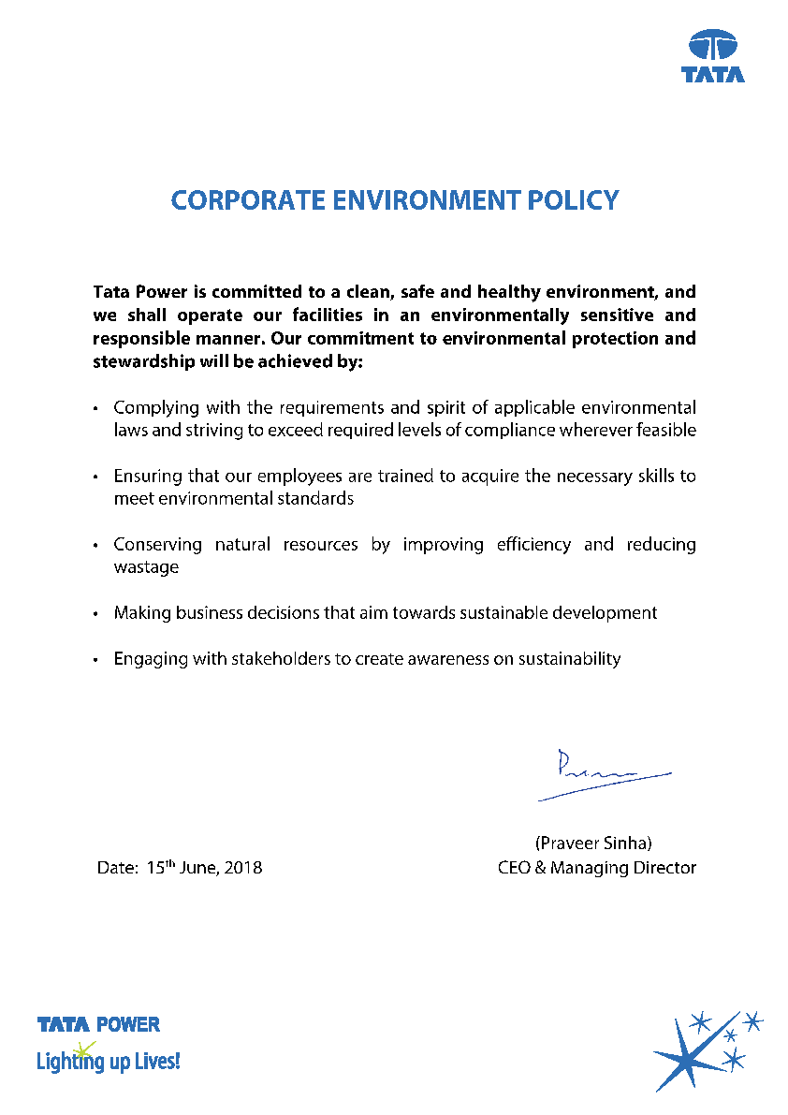



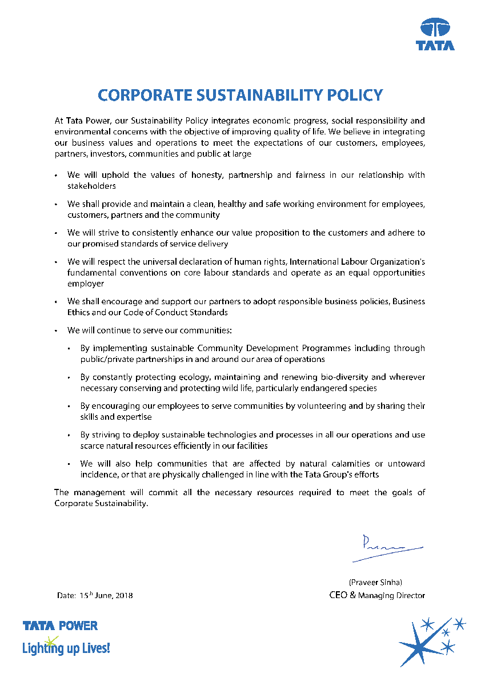

##### ANNEXURE-XI

1. **Tender Fees**

**Norms for procurement from MSMEs registered in the state of Odisha**

To participate in the tender, MSMEs registered in the State of Odisha shall pay Rs.1,000/- including GST towards cost of tender paper.

1. **Earnest Money Deposit (EMD)**

EMD shall be exempted for MSME registered in the State of Odisha. However, Bidder shall be barred to participate in the tendering process for a period of 2 years in case it backs out post award of the contract.



1. **Qualification Requirement for Open Tenders**

Qualification Requirement of Financial Turnover for MSME registered in the State of Odisha shall be reduced to 20% of the existing criteria.

1. **Performance Bank Guarantees**

Performance Bank Guarantee for MSME registered in the State of Odisha shall be 25% of the value prescribed.

**NIT No.:** TPWODL/PJ/O/SU/001



# Technical Specifications (Annexure to Tender Documents)

***Property of TPWODL – Not to be reproduced without prior written permission of TPWODL***